**SPRINT 2**

|  |  |
| --- | --- |
| TEAM ID | PNT2022TMID51155 |
| PROJECT NAME | Smart Fashion Recommender Application |

**CODE AND TEST CASES: finalhome.html**

<html>

<head>

<meta name="viewpoint" content="width=device-width, initial-scale=1.0">

<title>BEYOND FASHION</title>

<link rel="stylesheet" href="https://storagedemo-madzh.s3.jp-tok.cloud-objectstorage.appdomain.cloud/MadmukFinalhomecss.css">

</head>

<body>

<nav>

<a class="logo" href="MadFinalhome.html"><h2>FASHIONISTA HOME</h2></a>

<ul>

<li><input class="srch" type="search" name="" placeholder="TYPE TO SEARCH">

<a href="#"><button class="btn">SEARCH</button></a></li>

<li><a href="#">HOME</a></li>

<li><a href="#">FEATURES</a></li>

<li><a href="#">ABOUT</a></li>

</ul>

<img src="https://storagedemo-madzh.s3.jp-tok.cloud-object-

storage.appdomain.cloud/images/profile.jpeg" class="user-pic" onclick="toggleMenu()">

<div class="sub-menu-wrap" id="subMenu">

<div class="sub-menu">

<div class="user-info">

<img src="https://storagedemo-madzh.s3.jp-tok.cloud-objectstorage.appdomain.cloud/images/profile.jpeg">

<h2>NAME</h2>

</div>

<hr>

<a href="#" class="sub-menu-link">

<img src="https://storagedemo-madzh.s3.jp-tok.cloud-objectstorage.appdomain.cloud/images/profile.jpeg">

<p>EDIT PROFILE</p>

</a>

<a href="#" class="sub-menu-link">

<img src="https://storagedemo-madzh.s3.jp-tok.cloud-objectstorage.appdomain.cloud/images/settings.jpeg">

<p>SETTING & PRIVACY</p>

</a>

<a href="#" class="sub-menu-link">

<img src="https://storagedemo-madzh.s3.jp-tok.cloud-objectstorage.appdomain.cloud/images/help.jpeg">

<p>HELP</p>

</a>

<a href="/Login" class="sub-menu-link">

<img src="https://cdn-icons-png.flaticon.com/512/56/56805.png">

<p>LOGOUT</p>

</a>

</div>

</div>

</nav>

<div class="Banner">

<div class="Bannerimg1"> <img img class="image" src="https://img.freepik.com/freephoto/joyful-parisian-woman-beret-sunglasses-points-place-text-purple-wall_19753124604.jpg?w=2000"></div>

<div class="Adcontent">

<h1><br>BEST FASHION FOR WOMEN</br></h1>

<br>ADD THESE NEW LAUNCHES TO YOUR CART NOW...</br>

</div>

</div>

<div class="rowstart">

<div class="columnst"> <div class="depimg"><img class="image"

src="https://cdn0.weddingwire.in/article/2617/original/1280/jpg/107162-wedding-dresses-for-girls-

6.jpeg"> </div> <div class="Bottom">WEDDING & FESTIVE</div> </div>

<div class="columnst"> <div class="depimg"><img class="image" src="https://previews.123rf.com/images/vadymvdrobot/vadymvdrobot1801/vadymvdrobot180102335/94 122785-full-length-image-of-smiling-asian-woman-in-business-clothes-and-eyeglasses-holdingsmartphone-while.jpg"> </div> <div class="Bottom">BACK TO DESK</div> </div>

<div class="columnst"> <div class="depimg"><img class="image"

src="https://i.pinimg.com/474x/29/00/fa/2900fa4d1599631766420338e531b2b2.jpg"> </div> <div class="Bottom">VACAY MOOD</div> </div>

<div class="columnst"> <div class="depimg"><img class="image"

src="https://img.faballey.com/images/Product/DRS02948Z/1.jpg"> </div> <div class="Bottom">PARTY ALL NIGHT</div> </div>

</div>

<div class="Banner">

<div class="Bannerimg2"> <img img class="image" src="https://bluejay.com.my/wpcontent/uploads/2021/12/Kids-clothes-Hong-Kong-seed.jpg"></div>

<div class="Adcontent2">

<h1><br>KIDS FASHION</br></h1>

<br>LET OUR FUTURE BE STYLISH.....</br>

</div>

</div>

<div class="row">

<div class="column"> <div class="depimg"><img class="image"

src="https://cdn.shopify.com/s/files/1/0266/6276/4597/files/floral_ethnic_wear_for_kids_by_utsa.jpg?v= 1597833877"> </div> <div class="Bottom">ETHNIC WEAR</div> </div>

<div class="column"> <div class="depimg"><img class="image"

src="https://i.pinimg.com/736x/8a/f8/59/8af859d60ef9667726b206e1be2378e4.jpg"> </div> <div class="Bottom">WINTER WEAR</div> </div>

<div class="column"> <div class="depimg"><img class="image"

src="https://i.pinimg.com/474x/9a/c2/85/9ac28569bd3bade0aa23bd74aaa8c0a9.jpg"> </div> <div class="Bottom">DRESSES & JUMPSUITS</div> </div>

<div class="column"> <div class="depimg"><img class="image"

src="https://i.pinimg.com/564x/1b/c1/d5/1bc1d56f08959760738a0386f231d3fc.jpg"> </div> <div class="Bottom">TOPS & TEES</div> </div>

</div>

<div class="Banner">

<div class="Bannerimg1"> <img img class="image"

src="https://images.hindustantimes.com/rf/image_size_630x354/HT/p2/2018/01/30/Pictures/_2166734205ba-11e8-90ea-37dc70df54a3.jpg"></div>

<div class="Adcontent">

<h1><br>MENS FASHION</br></h1>

<br>WE ALSO PROVIDE TRENDY COLLECTIONS FOR MEN..ALWAYS "MEN WILL BE MEN"</br>

</div>

</div>

<div class="row">

<div class="column"> <div class="depimg"><img class="image" src="https://encryptedtbn0.gstatic.com/images?q=tbn:ANd9GcRPYVjlrL-

LxLn_nhnDfHJx09_dUQsTRgkM69nENo7WKE6EKe555GjYDI7leLNGsKyGvR8&usqp=CAU"> </div> <div class="Bottom">T-SHIRTS & POLOS</div> </div>

<div class="column"> <div class="depimg"><img class="image" src="https://encryptedtbn0.gstatic.com/images?q=tbn:ANd9GcTIFeIqHpb2srr3FnKvSDnAUdz225j0v_Ijo-

KuIZzvS2O5LHuyxBNYzfy8HgQ_Hi6WbDQ&usqp=CAU"> </div> <div class="Bottom">CASUAL SHIRTS</div> </div>

<div class="column"> <div class="depimg"><img class="image" src="https://assets.myntassets.com/dpr_1.5,q_60,w_400,c_limit,fl_progressive/assets/images/10498568/2 020/6/10/f1bc48ac-9997-4be1-8ce3-81cc6d5e61061591736177979-HRX-by-Hrithik-Roshan-Men-Grey-

Solid-Regular-Fit-Training-Jo-1.jpg"> </div> <div class="Bottom">SPORTS WEAR</div> </div>

<div class="column"> <div class="depimg"><img class="image" src="https://images.express.com/is/image/expressfashion/0037_04105431_0512?cache=on&wid=361&f mt=jpeg&qlt=75,1&resmode=sharp2&op_usm=1,1,5,0&defaultImage=Photo-Coming-Soon"> </div> <div class="Bottom">SWEATSHIRTS & JACKETS</div> </div>

</div>

<div class="Banner">

<div class="Bannerimg2"> <img class="image"

src="https://lh3.googleusercontent.com/KDJ_WZU_7c-

GHi14G03oqXb6ZSgTiDJr8L7Rid5jA9pRPAdUOgfQQYAPDLGN9Sn3eJC6B1F4qchid_0mHWn_jfic Xrs=w400-rw"></div>

<div class="Adcontent2">

<h1><br>ACCESSORIES</br></h1>

<br>THE ANOTHER THING WHICH MAKES A PERSON FASHIONABLE IS

ACCESSORIES</br>

</div>

</div>

<div class="rowend">

<div class="columnend"> <div class="depimg"><img class="image"

src="https://5.imimg.com/data5/FJ/AH/MY-42396081/combo-sets-28american-diamond-jewellery-29500x500.jpg"> </div> <div class="Bottom">JEWELLERY</div> </div>

<div class="columnend"> <div class="depimg"><img class="image" src="https://encryptedtbn0.gstatic.com/images?q=tbn:ANd9GcTaoxLoX2lgaVWFtaGkCvyrozucBLTpaV4LJd9xx2sRoqoums9 kp9soRVXOKw6_rkVxsZk&usqp=CAU"> </div> <div class="Bottom">SUNGLASSES</div> </div>

<div class="columnend"> <div class="depimg"><img class="image" src="https://encryptedtbn0.gstatic.com/images?q=tbn:ANd9GcRJKjvaIU1qatbXinxMNRfWE338fXEl7t69TQ&usqp=CAU"> </div> <div class="Bottom">WATCHES</div> </div>

<div class="columnend"> <div class="depimg"><img class="image" src="https://encryptedtbn0.gstatic.com/images?q=tbn:ANd9GcQSWDKgpQeZ-3VNR7-

9SfaVGVvqOawrkZiLdNfSpjNNQJNI6hl8cJg0Qs_DZfpJtizUst0&usqp=CAU"> </div> <div class="Bottom">HANDBAGS & CLUTCHES</div> </div>

</div>

<script>

let subMenu = document.getElementById("subMenu"); function toggleMenu(){ subMenu.classList.toggle("open-menu");

}

</script>

</body>

<footer>

<div class="footer"> <H1>HAPPY SHOPPING</H1></div>

</footer>

</html>

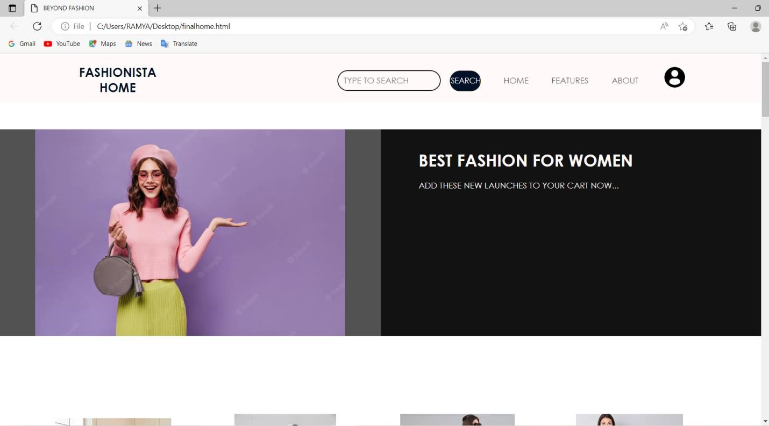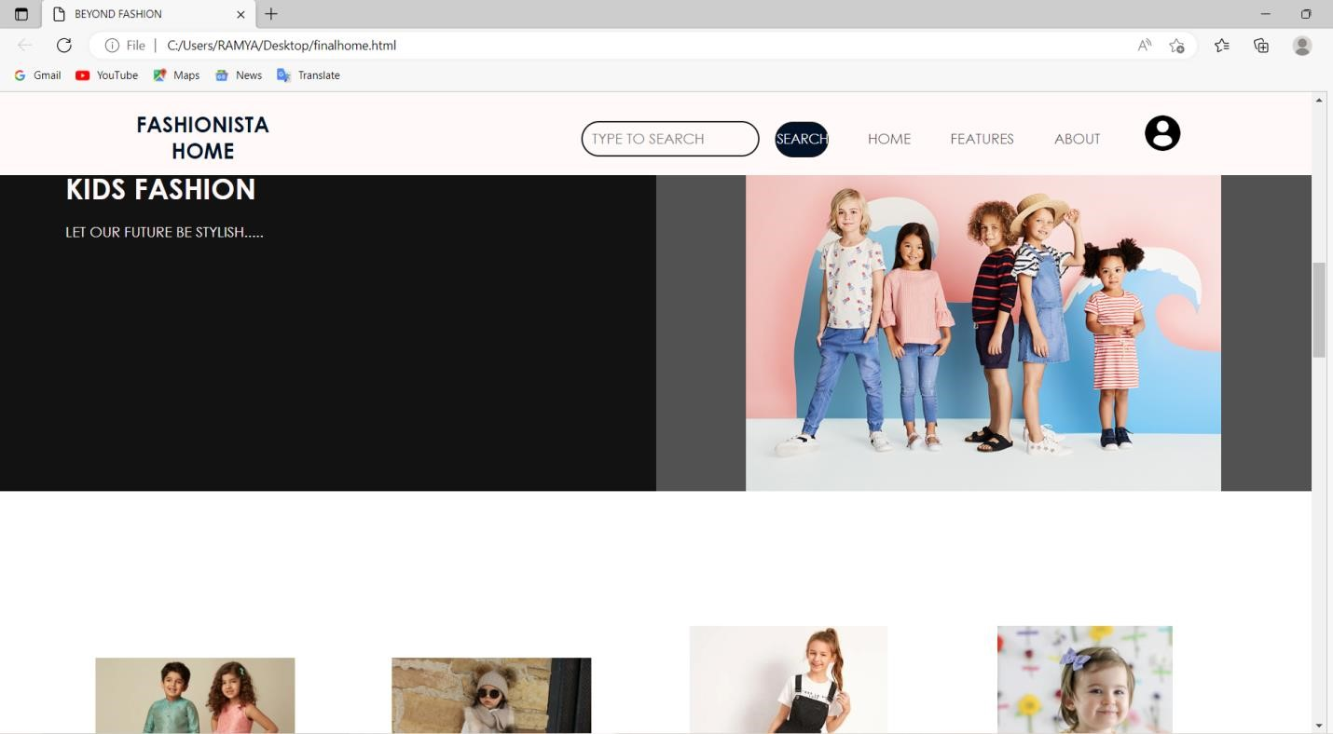

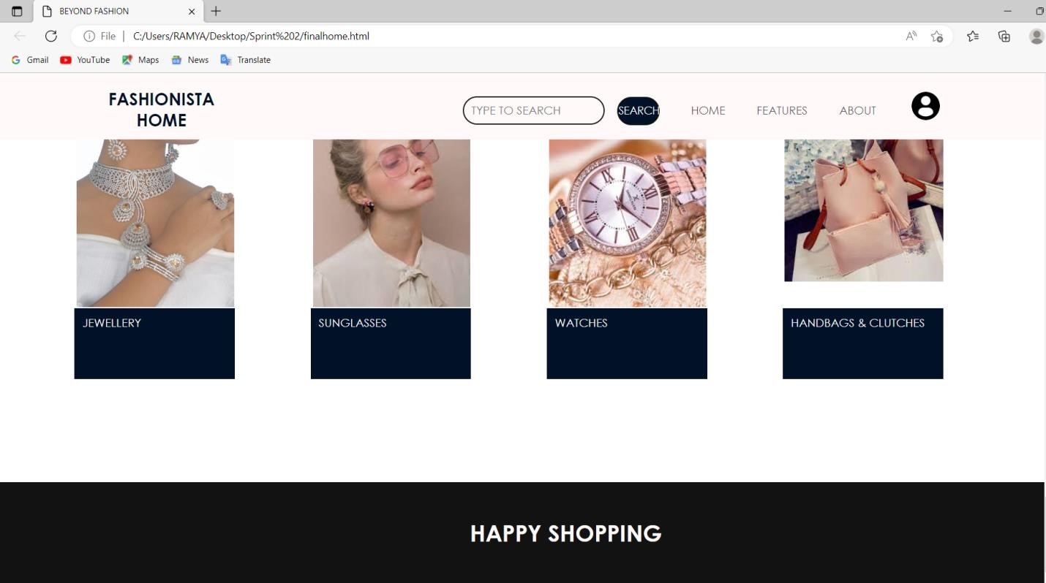 **login.html**

<html>

<head>

<meta name="viewpoint" content="width=device-width, initial-scale=1.0">

<title>BEYOND FASHION</title>

<link rel="stylesheet" href="https://storagedemo-madzh.s3.jp-tok.cloud-objectstorage.appdomain.cloud/Regcss.css">

</head>

<body>

<div class="main">

<div class="navbar">

<div class="menu">

<ul>

</ul>

</div>

</div>

<div class="content">

<h1> SMART FASHION <br><span>APPLICATION</span></h1>

<div class="form">

<h2>FASHIONISTA LOGIN</h2>

<form action="/Login" method="post">

<input type="text" name="username" placeholder="ENTER USERNAME">

<input type="password" name="password" placeholder="ENTER PASSWORD">

<button type="SUBMIT" class="btnn"><a href="#">LOGIN</a></button>

<p class="link">DON'T HAVE AN ACCOUNT<br>

<a href="/Register">SIGN UP </a> HERE </a></p>

</form>

</div> </div </div>

</body>

</html>

